**DSA Assignment – 27th June**

**Name – Karan Joshi**

**Roll No. – 23/11/EC/036**

**Leetcode Id – Karan_Joshi068048**

**Geeksforgeeks Id – wwwjoshikaran3424**

**Github Repo Link -** [**https://github.com/KaranJoshi101/urban-octo-robot/**](https://github.com/KaranJoshi101/urban-octo-robot/)

DSA-Section -

Question 1: Add Two Numbers

Platform: LeetCode

Problem Link: <https://leetcode.com/problems/add-two-numbers/>

Submission Screenshot:

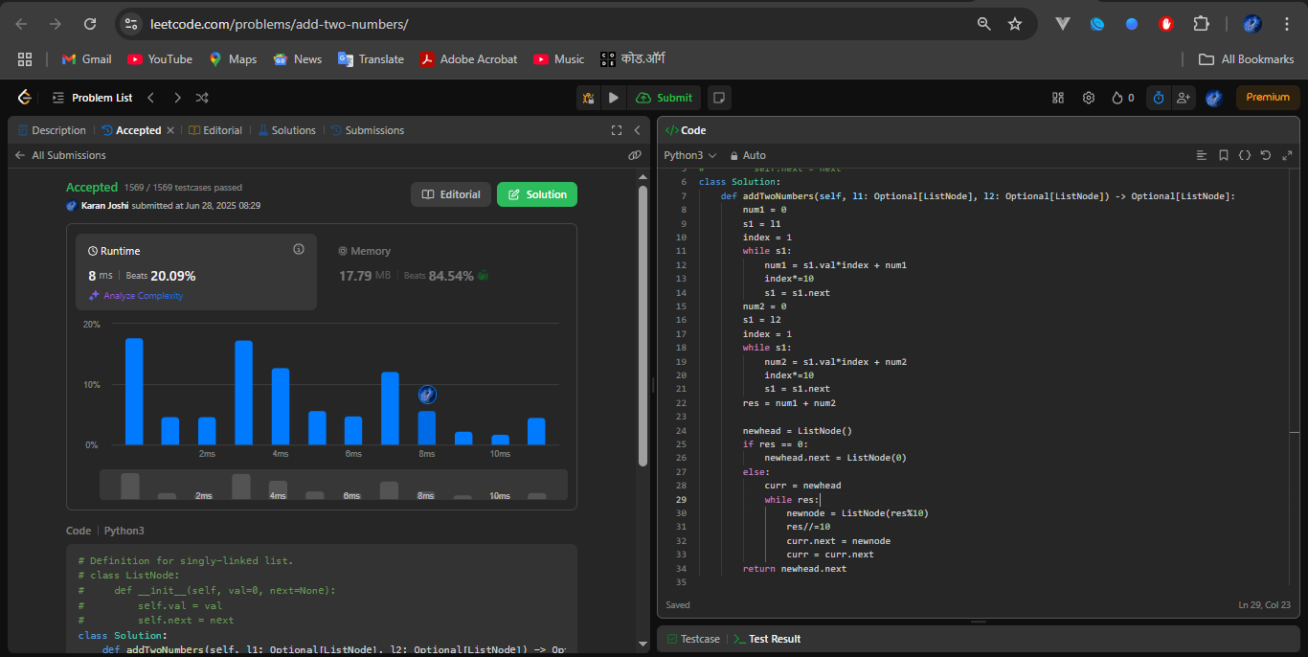

Question 2: Maximum Twin Sum

Platform: LeetCode

Problem Link: <https://leetcode.com/problems/maximum-twin-sum-of-a-linked-list/description/>

Submission Screenshot:

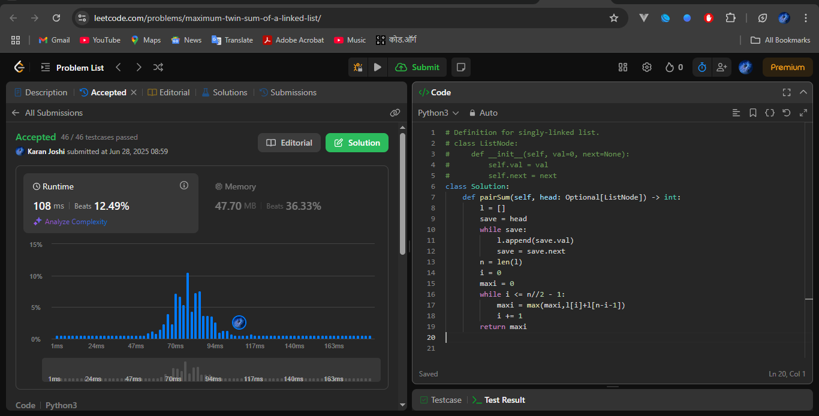

Question 3: Design Browser History

Platform: LeetCode

Problem Link: <https://leetcode.com/problems/design-browser-history/description/>

Submission Screenshot:

